

SCHOOL OF COMPUTER SCIENCE ENGINEERING
A COURSE BASED REPORT (IOT and Applications)
ON
“IoT-Based Automatic Plant Watering System using ESP8266 and Blynk”
Submitted in fulfillment of the requirements for the award of the Degree of

BACHELOR OF TECHNOLOGY IN ARTIFICIAL INTELLIGENCE & DATA SCIENCE
Submitted by
Edwin John | (R25EH044)
Anish Kumar Sah | (R25EH017)
Anish Madhav Joglekar | (R25EH018)
Chinmayanandhu NK | (R25EH034)
Under the guidance of
Prof Pratima A
Assistant professor, School of ECE
REVA University
July 2026
Rukmini Knowledge Park, Kattigenahalli, Yelahanka, Bengaluru-560064
www.reva.edu.in
I

DECLARATION
We, Edwin John (R25EH044), Anish Kumar Sah (R25EH017), Anish Madhav Joglekar
(R25EH018),Chinmayanandhu NK(R25EH034), students of B.Tech, belongs to School of Computer Science Engineering, REVA University, declare that this IOT Report “ IoT-Based Automatic Plant Watering System using ESP32 and Blynk” is the result of work done by us under the supervision of Prof Pratima A, Assistant Professor School of ECE REVA University, Bengaluru.
We are submitting this Report in partial fulfillment of the requirements for the completion of Course in IOT and Applications in II-Semester of Bachelor of Technology in AI & DS by the REVA University, Bengaluru during the academic year 2026-2027.
(Signature of the Students)
July 2026
Certified that this work submitted by Edwin John (R25EH044), Anish Kumar Sah (R25EH017), Anish Madhav Joglekar,(R25EH018),Chinmayanandhu NK(R25EH034) has been carried out under our guidance and the declaration made by the candidates is true to the best of our knowledge.
Signature of Faculty | Signature of Director
Date: July 2026 | Date: July 2026  Official Seal of the School
Name of the Examiner with affiliation  1.  2 | Signature with Date
II

List of Figures and Tables |  | 2
Abstract |  | 3
Chapter-I | 1.1 Introduction | 4-8
 | 1.2 Objectives
 | 1.3 Hardware and Software used
 | 1.4 Block diagram
Chapter-II | 2. Literature Survey | 9-10
Chapter-III | 3.1 Hardware components | 11-25
 | 3.2 Software used
Chapter-IV | 4.1 Work | 26-31
 | 4.2 Results and Analysis
Chapter-V | 5.1 Conclusion | 32
 | 5.2 Future Scope
References |  | 33

LIST OF FIGURES AND TABLES
Figure No. | Figure Title | Page No.
Figure 1 | Block Diagram of IoT-Based Smart Plant Watering System | 8
Figure 2 | Pin Details of NodeMCU ESP8266 | 12
Figure 3 | Pin Details of Capacitive Soil Moisture Sensor | 13
Figure 4 | Pin Details of Relay Module | 14
Figure 5 | Pin Details of LDR Module | 15
Figure 6 | LED Indicator | 16
Figure 7 | Breadboard and Jumper Wires | 17
Figure 8 | Arduino IDE | 18
Figure 9 | Arduino IDE Tabs | 19
Figure 10 | Blynk IoT Platform | 21
Figure 11 | Blynk Template and Datastream | 22
Figure 12 | Blynk Dashboard | 23
Figure 13 | Blynk Library Dashboard | 24
Figure 14 | Hardware Setup of Smart Plant Watering System | 26
Figure 15 | Circuit Diagram of Smart Plant Watering System | 27
Figure 16 | Blynk Dashboard Analysis | 31

ABSTRACT
In recent years, the rapid advancement of the Internet of Things (IoT) has enabled the development of smart automation systems in various fields, including agriculture and home gardening. This project presents an IoT-Based Smart Plant Watering System designed to automate the irrigation process and ensure healthy plant growth by continuously monitoring soil moisture levels. The system utilizes the NodeMCU ESP8266, a Wi-Fi-enabled microcontroller, to collect real-time data from a Capacitive Soil Moisture Sensor and control the watering process automatically. When the soil moisture falls below a predefined threshold, the NodeMCU activates a relay module, which switches on a Mini DC Water Pump to irrigate the plant. Once the desired moisture level is achieved, the pump is turned off automatically, thereby preventing overwatering and conserving water.
The proposed system is integrated with the Blynk IoT platform, which provides real-time monitoring and remote control through a smartphone application. Users can view the current soil moisture level, monitor the pump status, detect day and night conditions using an LDR sensor, and manually control the water pump whenever required. The Arduino IDE is used for programming the NodeMCU using Embedded C, while Wi-Fi connectivity enables seamless communication between the hardware and the Blynk cloud. The developed system offers an efficient, low-cost, and user-friendly solution for automatic plant irrigation, reducing manual effort and promoting efficient water utilization for home gardens, indoor plants, greenhouses, and small-scale agricultural applications.
Keywords: NodeMCU ESP8266, Capacitive Soil Moisture Sensor, Relay Module, Mini DC Water Pump, LDR Sensor, Blynk IoT, Wi-Fi, Arduino IDE, Smart Irrigation, Automatic Plant Watering System.

Chapter I: Introduction

1.1 INTRODUCTION
The rapid advancement of the Internet of Things (IoT) has transformed the way everyday objects interact with users by enabling real-time monitoring, automation, and remote control. IoT technology connects physical devices such as sensors, actuators, and microcontrollers to the internet, allowing them to collect data, communicate with cloud platforms, and perform intelligent actions without continuous human intervention. These technologies are increasingly being adopted in various fields including healthcare, smart homes, industrial automation, environmental monitoring, and agriculture. One of the most practical applications of IoT in agriculture and home gardening is the development of smart plant monitoring and automatic irrigation systems.
Plants require an adequate amount of water for healthy growth and survival. However, maintaining the correct moisture level is often difficult due to busy lifestyles, irregular schedules, or lack of knowledge about plant care. Many people either forget to water their plants or provide excessive water, both of which can negatively affect plant health. Underwatering causes plants to dry out and eventually die, while overwatering may lead to root rot, fungal infections, and nutrient loss. This problem becomes even more significant when people travel for extended periods or manage multiple plants simultaneously. Therefore, an intelligent and automated plant watering system is an effective solution to ensure plants receive the right amount of water at the right time.
The IoT-Based Smart Plant Watering System is designed to automate the irrigation process by continuously monitoring the moisture level of the soil using a capacitive soil moisture sensor. The sensor sends real-time moisture data to the NodeMCU ESP8266, which acts as the central controller of the system. The NodeMCU processes the sensor readings and compares them with a predefined moisture threshold. Whenever the soil moisture falls below the desired level, the controller automatically activates a relay module, which switches on a mini water pump to irrigate the plant. Once sufficient moisture has been restored, the controller turns off the pump, thereby preventing unnecessary water usage and protecting the plant from overwatering.
In addition to automatic watering, the system incorporates IoT technology through the Blynk platform, enabling users to remotely monitor and control the watering system using a smartphone. The mobile application displays important information such as the current soil moisture level, pump status, and lighting condition. Users can also manually operate the water pump whenever required using the mobile interface. This remote accessibility makes the system highly convenient and allows users to care for their plants even when they are away from home.
The project also includes a Light Dependent Resistor (LDR) to detect ambient lighting conditions. The LDR helps determine whether it is daytime or nighttime and sends this information to the Blynk dashboard for monitoring. An LED indicator is provided to visually indicate the operational status of the system. When the pump is activated, the LED also turns ON, providing an immediate indication that watering is currently taking place. These additional features improve the usability and monitoring capabilities of the overall system.
The NodeMCU ESP8266 is selected as the primary controller because it combines a powerful microcontroller with built-in Wi-Fi connectivity, making it ideal for IoT-based applications. Programming is performed using the Arduino IDE with Embedded C, while the Blynk cloud platform facilitates secure communication between the hardware and the mobile application. The system periodically reads sensor values, uploads them to the cloud, updates the mobile dashboard, and automatically controls the water pump based on the programmed decision logic. This automation significantly reduces manual effort while ensuring efficient water management.
The proposed Smart Plant Watering System is suitable for home gardens, indoor plants, offices, balconies, greenhouses, and small-scale agricultural applications. It provides an affordable, reliable, and energy-efficient solution for plant care while promoting water conservation through intelligent irrigation. Compared to traditional manual watering methods, the system offers greater convenience, real-time monitoring, remote accessibility, and improved plant health.
Overall, the IoT-Based Smart Plant Watering System demonstrates the practical application of embedded systems, sensors, wireless communication, cloud computing, and automation in solving a real-world problem. The project serves as an excellent example of integrating electronics, programming, and IoT technologies into a single smart solution that enhances plant care while reducing human effort. It also provides a foundation for future enhancements such as weather-based irrigation, water level monitoring, AI-based watering prediction, solar-powered operation, and support for multiple plants, making it a scalable and intelligent smart agriculture solution.
1.2 Objectives
The main objective of the proposed IoT-Based Smart Plant Watering System is to develop an intelligent and automated irrigation system that monitors soil moisture in real time and waters plants only when necessary. The system aims to reduce manual effort, conserve water, and ensure healthy plant growth through IoT technology and automation.
The specific objectives of the project are:
- To design and develop an IoT-based automatic plant watering system using the NodeMCU ESP8266 microcontroller.
- To continuously monitor the soil moisture level using a Capacitive Soil Moisture Sensor.
- To automatically activate the water pump whenever the soil moisture falls below a predefined threshold.
- To stop watering automatically once sufficient soil moisture has been achieved, preventing overwatering.
- To enable real-time monitoring of plant conditions through the Blynk IoT mobile application.
- To provide manual control of the water pump from a smartphone whenever required.
- To detect day and night conditions using an LDR sensor and display the information on the mobile dashboard.
- To provide visual indication of the pump status using an LED indicator.
- To minimize water wastage through intelligent irrigation control.
- To develop a low-cost, efficient, and user-friendly smart gardening solution suitable for homes, offices, balconies, greenhouses, and small-scale agricultural applications.

1.3 Hardware and Software Used
The proposed Smart Plant Watering System consists of various hardware and software components that work together to monitor soil moisture, automate irrigation, and provide remote monitoring and control through IoT technology.
1.3.1 Hardware Used
The following hardware components are used in this project:
- NodeMCU ESP8266 Development Board
  - Acts as the main controller of the system.
  - Reads sensor data and controls the relay and water pump.
  - Provides built-in Wi-Fi connectivity for IoT communication with the Blynk cloud.
- Capacitive Soil Moisture Sensor V1.2
  - Measures the moisture content present in the soil.
  - Sends analog values to the NodeMCU.
  - Helps determine whether watering is required.
- 1-Channel 5V Relay Module
  - Works as an electrically controlled switch.
  - Allows the low-voltage NodeMCU to safely control the 5V water pump.
- 5V Mini DC Water Pump
  - Pumps water from the water tank to the plant.
  - Operates automatically based on soil moisture conditions.
- Light Dependent Resistor (LDR) Module
  - Detects ambient light intensity.
  - Determines whether it is daytime or nighttime.
  - Sends the information to the Blynk dashboard.
- LED Indicator
  - Indicates the operational status of the system.
  - Turns ON whenever the water pump is activated.
- 5V Power Adapter
  - Supplies power to the NodeMCU, relay module, and water pump.
- Breadboard
  - Used for assembling the circuit without soldering.
- Jumper Wires
  - Used to establish electrical connections between various components.
- Silicone Water Pipe
  - Carries water from the water reservoir to the plant.
- Water Tank
  - Stores water used by the pump for irrigation.

1.3.2 Software Used
The software tools used for developing the Smart Plant Watering System are:
- Arduino IDE
  - Used to write, compile, and upload Embedded C programs to the NodeMCU ESP8266.
- Embedded C
  - Programming language used for implementing the system logic, sensor monitoring, and automation.
- Blynk IoT Platform
  - Cloud-based IoT platform used for remote monitoring and manual control through a smartphone.
  - Displays soil moisture values, pump status, and light condition.
- ESP8266 Board Package
  - Installed in the Arduino IDE to enable programming of the NodeMCU ESP8266 board.
- ESP8266WiFi Library
  - Provides Wi-Fi connectivity between the NodeMCU and the internet.
- Blynk Library
  - Enables communication between the NodeMCU and the Blynk cloud server.
- Serial Monitor (Arduino IDE)
  - Used for debugging, displaying sensor readings, and monitoring system operation during development.
These hardware and software components collectively enable the Smart Plant Watering System to perform automatic irrigation, real-time monitoring, manual control, and efficient water management through IoT technology.

1.4 Block Diagram
The block diagram of the proposed IoT-Based Smart Plant Watering System using NodeMCU ESP8266 and Blynk is shown in Figure 1. It illustrates the overall architecture of the system, including the NodeMCU ESP8266, soil moisture sensor, LDR sensor, relay module, water pump, Blynk cloud platform, and mobile application used for real-time monitoring and automatic plant watering.
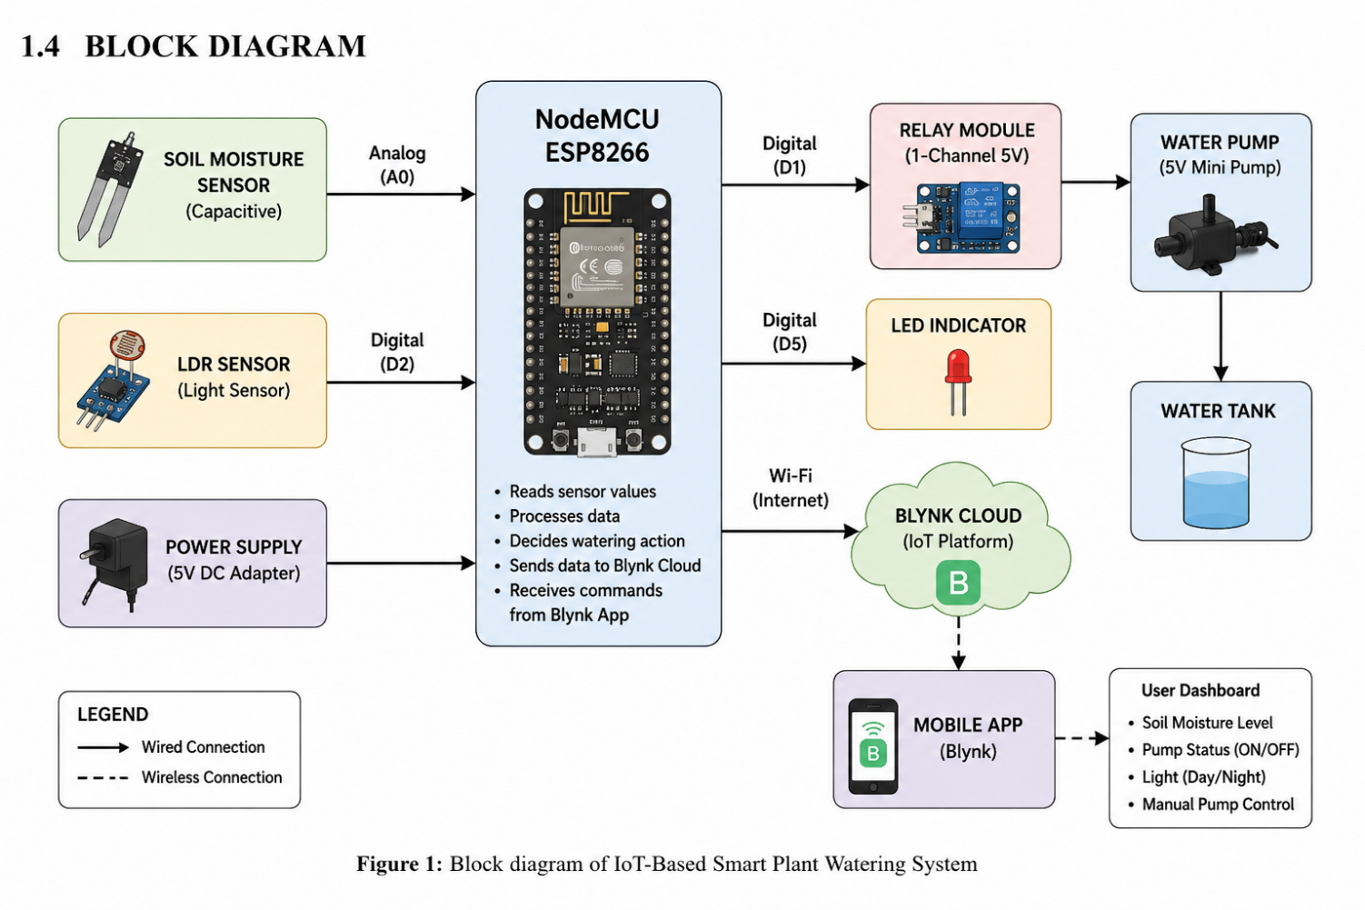
Figure 1 | Block Diagram of IoT-Based Smart Plant Watering System

Chapter II: Literature Survey

1. IoT-Based Automatic Watering and Monitoring System for Greenhouse

International Journal of Scientific Research in Computer Science, Engineering and Information Technology (IJSRCSEIT), Volume 8, Issue 3, 2022.

The system proposed in this paper presents an IoT-based automatic watering and monitoring solution for greenhouse applications. The main objective of the system is to monitor soil moisture continuously and automatically irrigate plants whenever the soil becomes dry. The proposed system uses a NodeMCU ESP8266 microcontroller integrated with a soil moisture sensor, relay module, and water pump. The moisture sensor continuously measures the water content in the soil and sends the data to the microcontroller for processing. When the moisture level falls below a predefined threshold, the NodeMCU automatically activates the relay to switch on the water pump. After the required moisture level is reached, the pump is turned off automatically to avoid overwatering.

The system also incorporates the Blynk IoT platform, enabling users to monitor soil moisture values, pump status, and other system information remotely through a smartphone application. Users can also manually control the water pump whenever necessary. The proposed solution helps reduce water wastage, minimizes human intervention, improves irrigation efficiency, and ensures healthy plant growth. The study concludes that IoT-based automatic irrigation systems provide an economical, reliable, and efficient solution for greenhouse and home gardening applications by combining real-time monitoring, wireless communication, and intelligent automation.

2. Design and Development of Smart Irrigation System Using NodeMCU ESP8266 and Blynk IoT

International Journal of Innovative Research in Science, Engineering and Technology (IJIRSET), Volume 11, Issue 6, 2022.

The research presented in this paper focuses on the design and development of a smart irrigation system using the NodeMCU ESP8266 microcontroller and the Blynk IoT platform. The proposed system continuously monitors the soil moisture level using a soil moisture sensor and automatically controls the irrigation process based on real-time sensor readings. Whenever the soil moisture falls below a predefined threshold, the NodeMCU activates a relay module that switches on the water pump to supply water to the plants. Once the soil reaches the required moisture level, the controller turns off the pump automatically, thereby conserving water and preventing over-irrigation.

The system uses the built-in Wi-Fi capability of the NodeMCU to transmit sensor data to the Blynk cloud, allowing users to monitor soil moisture, pump status, and system performance through a smartphone application. The Blynk platform also provides manual control of the water pump, enabling users to operate the irrigation system remotely whenever required. The study concludes that the proposed IoT-based irrigation system improves water management, reduces manual labor, enhances plant health, and provides a cost-effective and efficient solution for home gardens, greenhouses, and small-scale agricultural applications.

3. Smart Plant Monitoring and Automatic Watering System Using IoT
International Journal of Advanced Research in Computer Science and Software Engineering (IJARCSSE), Volume 10, Issue 4, 2021.
This paper presents an IoT-based smart plant monitoring and automatic watering system developed to improve plant care through automation and remote monitoring. The proposed system uses a NodeMCU ESP8266 microcontroller, a soil moisture sensor, and a relay-controlled water pump to maintain the required moisture level in the soil. The moisture sensor continuously measures the soil condition and sends the readings to the microcontroller. When the soil becomes dry, the NodeMCU automatically activates the relay module, which switches on the water pump to irrigate the plant. Once the desired moisture level is achieved, the controller turns off the pump automatically, ensuring efficient water usage and preventing overwatering.
The system is integrated with the Blynk IoT platform, allowing users to monitor soil moisture levels, pump status, and other system parameters through a smartphone application. The mobile application also provides manual control of the irrigation system whenever required. The study highlights that the proposed IoT solution reduces human effort, conserves water, improves plant health, and provides an efficient and user-friendly approach for home gardening, indoor plants, greenhouses, and small-scale agricultural applications.
4. IoT-Based Smart Irrigation System for Efficient Water Management
Procedia Computer Science, Volume 160, 2019. Authors: Jash Doshi, Tirthkumar Patel.
This paper presents an IoT-based smart irrigation system developed to improve water management and increase agricultural productivity through automation. The proposed system integrates NodeMCU ESP8266, soil moisture sensors, temperature and humidity sensors, and a relay-controlled water pump to continuously monitor field conditions. Sensor data is collected in real time and transmitted to the cloud using Wi-Fi technology, allowing farmers to monitor crop conditions remotely through a mobile application. Whenever the soil moisture level falls below the predefined threshold, the controller automatically activates the irrigation system and switches it off once the required moisture level is achieved.
The system also provides real-time notifications and remote monitoring, enabling users to make informed decisions regarding irrigation and crop management. By utilizing IoT technology, the proposed solution reduces water wastage, minimizes manual labor, and ensures efficient utilization of available water resources. The study concludes that smart irrigation systems can significantly improve farming efficiency, conserve water, and support sustainable agricultural practices while providing an economical and reliable solution for modern agriculture.

Chapter III: Implementation

The implementation block diagram of the IoT-Based Smart Plant Watering System is shown in the figure. In this project, the Capacitive Soil Moisture Sensor continuously monitors the soil moisture level, while the LDR sensor detects the ambient light condition. The NodeMCU ESP8266 processes the sensor data and automatically controls the water pump through a relay module whenever the soil becomes dry. The sensor readings, pump status, and day/night condition are transmitted to the Blynk IoT Cloud over a Wi-Fi connection. The Arduino IDE is used to develop the Embedded C program, and the Blynk mobile application enables real-time monitoring
3.1 Hardware components:

3.1.1 ESP8266 NodeMCU Microcontroller Board
The NodeMCU (Node Micro Controller Unit) is an open-source software and hardware development environment built around an inexpensive System-on-a-Chip (SoC) called the ESP8266. The ESP8266, designed and manufactured by Espressif Systems, contains the crucial elements of a computer: CPU, RAM, networking (Wi-Fi), and even a modern operating system and SDK. That makes it an excellent choice for Internet of Things (IoT) projects of all kinds. However, as a chip, the ESP8266 is also hard to access and use. You must solder wires, with the appropriate analog voltage, to its pins for the simplest tasks such as powering it on or sending a keystroke to the “computer” on the chip. You also have to program it in low-level machine instructions that can be interpreted by the chip hardware. This level of integration is not a problem using the ESP8266 as an embedded controller chip in mass-produced electronics. It is a huge burden for hobbyists, hackers, or students who want to experiment with it in their own IoT projects.
The Arduino project created an open-source hardware design and software SDK for their versatile IoT controller. Similar to NodeMCU, the Arduino hardware is a microcontroller board with a USB connector, LED lights, and standard data pins. It also defines standard interfaces to interact with sensors or other boards. But unlike NodeMCU, the Arduino board can have different types of CPU chips (typically an ARM or Intel x86 chip) with memory chips, and a variety of programming environments. There is an Arduino reference design for the ESP8266 chip as well. However, the flexibility of Arduino also means significant variations across different vendors. For example, most Arduino boards do not have Wi-Fi capabilities, and some even have a serial data port instead of a USB port.
The NodeMCU is available in various package styles. Common to all the designs is the base ESP8266 core. Designs based on the architecture have maintained the standard 30-pin layout. Some designs use the more common narrow (0.9″) footprint, while others use a wide (1.1″) footprint – an important consideration to be aware of. The most common models of the NodeMCU are the Amica (based on the standard narrow pin-spacing) and the LoLin which has the wider pin spacing and larger board. The open-source design of the base ESP8266 enables the market to design new variants of the NodeMCU continually.
The Pin diagram of NodeMCU ESP8266 is as shown
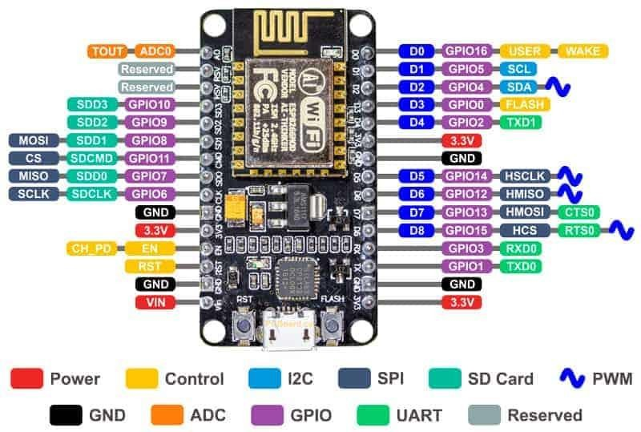
3.1.2 Capacitive Soil Moisture Sensor
The Capacitive Soil Moisture Sensor is used to measure the moisture content present in the soil. Unlike resistive moisture sensors, the capacitive sensor detects soil moisture by measuring changes in capacitance, making it resistant to corrosion and suitable for long-term use. It provides an analog output that varies according to the moisture level of the soil. The sensor can be easily interfaced with microcontrollers such as the NodeMCU ESP8266, Arduino, and ESP32 for smart irrigation applications.
It is a 3-terminal sensor used to measure the moisture content of soil for automatic irrigation and plant monitoring.
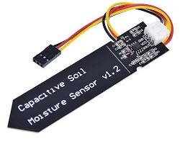
Figure 3 | Pin Details of Capacitive Soil Moisture Sensor

Capacitive Soil Moisture Sensor Pinout:
The pin diagram of the Capacitive Soil Moisture Sensor is as shown .
Fig.4 Pin details of Capacitive Soil Moisture Sensor
- VCC: Supply Voltage (3.3V–5V)
- GND: Ground
- AOUT: Analog output proportional to soil moisture level
Specifications of Capacitive Soil Moisture Sensor
- Operating Voltage: 3.3V to 5V DC
- Output Type: Analog
- Low Power Consumption
- Corrosion Resistant
- Suitable for Long-Term Soil Monitoring
- Compact PCB Design
- Compatible with Arduino, ESP8266, and ESP32

3.1.3 Relay Module
The Relay Module is an electrically operated switch used to control high-current devices using a low-voltage microcontroller. In this project, the relay acts as an interface between the NodeMCU ESP8266 and the Mini DC Water Pump. Whenever the NodeMCU detects dry soil, it energizes the relay, allowing power to flow to the water pump.
The relay provides electrical isolation between the control circuit and the load circuit, ensuring safe operation of the system.
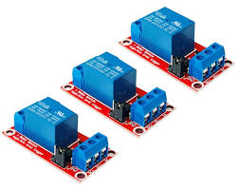
Figure 4 | Pin Details of Relay Module

Relay Module Pinout:
The pin diagram of the Relay Module is as shown in Figure 5.
Fig.5 Pin details of Relay Module
- VCC: Supply Voltage (5V)
- GND: Ground
- IN: Control input from NodeMCU
- COM: Common Terminal
- NO: Normally Open Contact
- NC: Normally Closed Contact
Specifications of Relay Module
- Operating Voltage: 5V DC
- Number of Channels: 1
- Trigger Type: Digital Input
- Opto-Isolated Protection
- LED Status Indicator
- Supports AC and DC Loads

3.1.4 Mini DC Water Pump
The Mini DC Water Pump is used to deliver water from the storage tank to the plant whenever irrigation is required. The pump operates only when the relay module receives a control signal from the NodeMCU. Due to its compact size and low power consumption, it is suitable for small-scale smart irrigation systems.
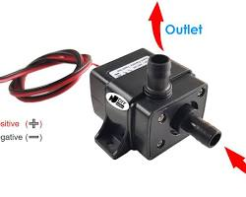

Mini DC Water Pump Specifications
- Operating Voltage: 3V–6V DC
- Rated Voltage: 5V DC
- Low Power Consumption
- Compact Size
- Continuous Water Flow
- Suitable for Indoor Plant Watering

3.1.5 LDR (Light Dependent Resistor) Sensor
The LDR (Light Dependent Resistor) Sensor is used to detect the surrounding light intensity. The sensor changes its resistance according to the amount of light falling on its surface. In this project, the LDR sensor determines whether it is daytime or nighttime and updates the status on the Blynk IoT application.
The LDR module provides a digital output that can be directly connected to the NodeMCU.
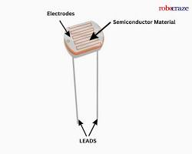
Figure 5 | Pin Details of LDR Module

LDR Module Pinout:
The pin diagram of the LDR Module is as shown in Figure 6.
Fig.6 Pin details of LDR Module
- VCC: Supply Voltage (3.3V–5V)
- GND: Ground
- DO: Digital Output
Specifications of LDR Module
- Operating Voltage: 3.3V–5V
- Output Type: Digital
- Adjustable Sensitivity
- Low Power Consumption
- Built-in Comparator Circuit
- Suitable for Day/Night Detection

3.1.6 LED Indicator
The LED Indicator is used to display the operational status of the irrigation system. Whenever the relay activates the water pump, the LED turns ON, indicating that watering is in progress. When the pump is switched OFF, the LED also turns OFF.
The LED provides a simple visual indication of system operation during testing and monitoring.
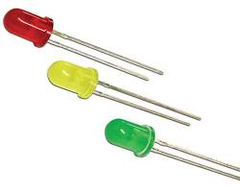
Figure 6 | LED Indicator

LED Pin Details
- Anode (+): Connected to NodeMCU Digital Pin (D5) through a current-limiting resistor
- Cathode (-): Connected to Ground
Specifications of LED
- Operating Voltage: 2V–3.3V
- Forward Current: 10–20 mA
- Low Power Consumption
- Long Operating Life
- Red Indicator LED

3.1.7 Power Supply
The Power Supply provides the necessary electrical energy required for the operation of the NodeMCU, relay module, sensors, and water pump. A regulated 5V DC power adapter is used to ensure stable voltage and reliable system performance.
Specifications of Power Supply
- Input Voltage: 230V AC
- Output Voltage: 5V DC
- Output Current: 1A–2A
- Regulated Output
- Overload Protection
- Short Circuit Protection

3.1.8 Breadboard and Jumper Wires
The Breadboard is a solderless prototyping board used for assembling electronic circuits without permanent connections. It allows easy testing, modification, and debugging of circuits during project development. Jumper wires are used to establish electrical connections between the NodeMCU, sensors, relay module, LED, and other components.
Specifications
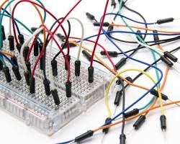
Figure 7 | Breadboard and Jumper Wires

Breadboard
- Type: Solderless Breadboard
- Tie Points: 830 (Typical)
- Reusable Design
- Easy Circuit Modification
Jumper Wires
- Type: Male-to-Male
- Flexible Copper Conductors
- PVC Insulation
- Suitable for Breadboard Connections

3.2 Software’s used:

3.2.1 Arduino IDE

The Arduino Integrated Development Environment - or Arduino Software (IDE) - contains a text editor for writing code, a message area, a text console, a toolbar with buttons for common functions and a series of menus. It connects to the Arduino hardware to upload programs and communicate with them.
Programs written using Arduino Software (IDE) are called sketches. These sketches are written in the text editor and are saved with the file extension . The editor has features for cutting/pasting and for searching/replacing text. The message area gives feedback while saving and exporting and also displays errors. The console displays text output by the Arduino Software (IDE), including complete error messages and other information. The bottom righthand corner of the window displays the configured board and serial port. The toolbar buttons allow you to verify and upload programs, create, open, and save sketches, and open the serial monitor.

a. Sketch
Once we open the IDE, it shows the option to open new sketch is as shown in figure.5
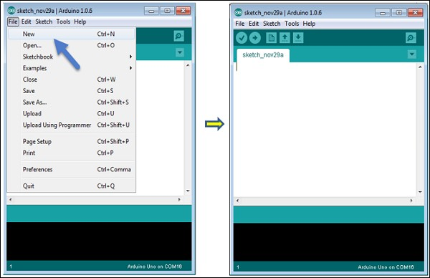
Fig.8 Arduino IDE
- Verify/Compile Checks your sketch for errors compiling it; it will report memory usage for code and variables in the console area.
- Upload Compiles and loads the binary file onto the configured board thro ugh the configured Port.
- Upload Using Programmer This will overwrite the bootloader on the board
; you will need to use Tools > Burn Bootloader to restore it and be able to Upload to USB serial port again. However, it allows you to use the full of the Flash memory for your sketch. Please note that this command will NOT burn the fuses. To do so a Tools -> Burn Bootloader command must be executed.
- Export Compiled Binary Saves a .hex file that may be kept as archive or sent to the board using other tools.
- Show Sketch Folder Opens the current sketch folder.
- Include Library Adds a library to your sketch by inserting #include statements at the start of your code. For more details, see libraries below. Additionally, from this menu item you can access the Library Manager and import new libraries from .zip files.
- Add File... Adds a supplemental file to the sketch (it will be copied from its current location). The file is saved to the data subfolder of the sketch, which is intended for assets such as documentation. The contents of the data folder are not compiled, so they do not become part of the sketch program.

b. Tabs, Multiple Files, and Compilation
The Tab buttons in Arduino IDE is as shown in figure 6
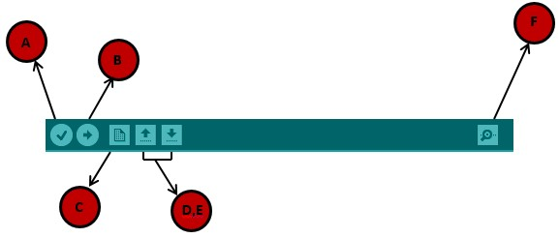

Fig.9 Tabs of Arduino IDE
Allows you to manage sketches with more than one file (each of which appears in its own tab). These can be normal Arduino code files (no visible extension), C files (.c extension), C++ files (.cpp), or header files (.h). Before compiling the sketch, all the normal Arduino code files of the sketch are concatenated into a single file following the order the tabs are shown in. The other file types are left as is.

c. Uploading
When we upload a sketch, you're using the Arduino bootloader, a small program that has been loaded on to the microcontroller on your board. It allows you to upload code without using any additional hardware. The bootloader is active for a few seconds when the board resets; then it starts whichever sketch was most recently uploaded to the microcontroller. The bootloader will blink the on-board (pin 13) LED when it starts (i.e. when the board resets).

3.2.2 CP2102 USB-UART serial device driver software
The CP2102 is a popular USB-to-UART (Universal Asynchronous Receiver/Transmitter) bridge chip developed by Silicon Labs. It serves as an interface between USB (Universal Serial Bus) and UART, allowing for serial communication between devices like microcontrollers and computers via a USB connection. This chip is commonly used in development boards, embedded systems, and electronic projects to facilitate communication with computers or other devices.

- The CP2102 allows microcontrollers or other embedded devices to communicate with a computer via USB, effectively creating a virtual COM (serial) port on the computer.
- The chip provides a standard UART interface with TX (transmit) and RX (receive) lines for serial communication. It may also have other UART-related pins like CTS, RTS, DTR, DSR, RI, and DCD, depending on the specific application requirements
- The CP2102 integrates multiple components on-chip, including a USB transceiver, clock, and voltage regulator, which helps reduce the number of external components required in a design.
- The CP2102 is commonly used in development boards like Arduino clones, ESP8266/ESP32 boards, and other microcontroller-based systems. It's used for programming and debugging microcontrollers, communicating with sensors or other peripherals, and enabling serial communication in various electronic projects

3.2.3 Embedded C for Arduino IDE
Embedded C is a subset of the C programming language designed for embedded systems, where memory and processing resources are more limited compared to general-purpose computers. It often requires a more hardware-oriented approach, focusing on direct interaction with hardware components like sensors, actuators, and communication interfaces.
Arduino provides a simplified environment for writing embedded C programs, commonly known as "sketches." While Arduino abstracts many hardware details to make it easier for beginners, you still write code in a version of C/C++.
To get started with embedded C on Arduino, you can use the following steps:
- Setup and Loop Functions: Every Arduino sketch has these two functions. setup() runs once at the beginning, and loop() runs repeatedly. This structure is typical in embedded systems to maintain a consistent program flow.
- Pin Control: Use pinMode() to set a pin as input or output, and digitalWrite(), digitalRead(), analogWrite(), or analogRead() to interact with them.
- Functions and Libraries: Write custom functions to organize your code, and use libraries for additional functionality. Libraries are key in embedded C programming as they abstract complex hardware interactions.
- Interrupts and Timers: Use attach Interrupt() to handle hardware interrupts. Timers can be managed with libraries or directly through registers.
- Communication Protocols: Work with common embedded communication protocols like
I2C, SPI, and UART. Arduino provides libraries like Wire (for I2C) and SPI

3.2.4 Blynk IoT Platform

Blynk IoT is a cloud-based platform designed for developing Internet of Things (IoT) applications with remote monitoring and control capabilities. It enables users to connect microcontrollers such as NodeMCU ESP8266, ESP32, Arduino, and Raspberry Pi to the internet and monitor sensor data through a smartphone application. Blynk provides an easy-to-use interface for creating custom dashboards without requiring extensive knowledge of mobile application development. It allows users to collect, visualize, and control data from IoT devices in real time from anywhere with an internet connection.

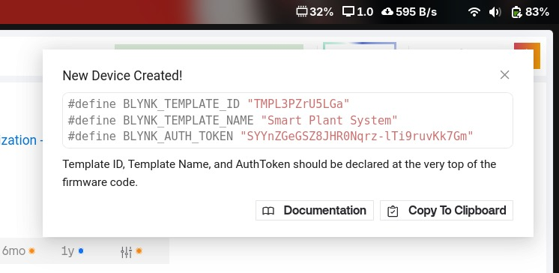
Figure 10 | Blynk IoT Platform

The Blynk platform consists of three main components: the Blynk Cloud, the Blynk IoT mobile application, and the Blynk Library installed in the microcontroller. The microcontroller communicates with the Blynk Cloud over Wi-Fi, while the mobile application retrieves data from the cloud and displays it on a customizable dashboard. Users can also send commands from the mobile application to control connected devices remotely. This makes Blynk an ideal platform for smart home automation, environmental monitoring, industrial automation, and smart agriculture applications.

In the proposed project, the NodeMCU ESP8266 continuously reads data from the Capacitive Soil Moisture Sensor and the LDR sensor and sends the information to the Blynk Cloud through Wi-Fi. The mobile application displays the soil moisture value, light condition (Day/Night), and pump status in real time. Users can also manually operate the water pump using a virtual button available on the Blynk dashboard. The platform eliminates the need for configuring web servers or developing a separate mobile application, making IoT implementation simple and efficient.

The core element of the Blynk platform is the Template and Datastream. A template defines the IoT project configuration, while datastreams are used to exchange data between the hardware device and the mobile dashboard. Each datastream is assigned a Virtual Pin (V0, V1, V2, etc.), which is used for transmitting sensor values and receiving control commands from the mobile application.

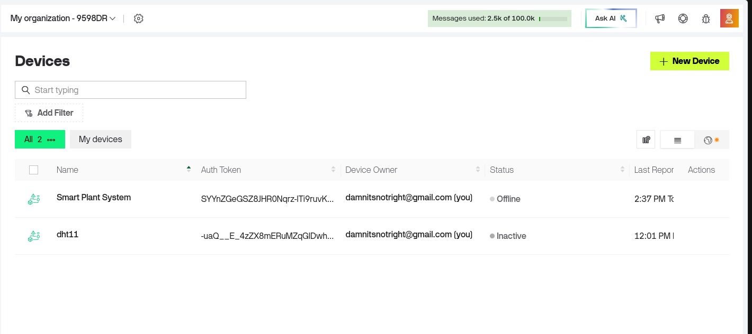
Figure 11 | Blynk Template and Datastream

The datastreams used in this project are:

V0 – Displays Soil Moisture Sensor Value.

V1 – Controls and displays the status of the Water Pump.

V2 – Displays the Light Condition (Daytime/Nighttime).

To use the Blynk IoT Platform, we first create a Blynk account and log in to the Blynk Console. A new Template is created by providing the template name and selecting the appropriate hardware (ESP8266) and connection type (Wi-Fi). After creating the template, the required datastreams are added and linked to the corresponding virtual pins. The generated Template ID, Template Name, and Authentication Token are then included in the Arduino program.
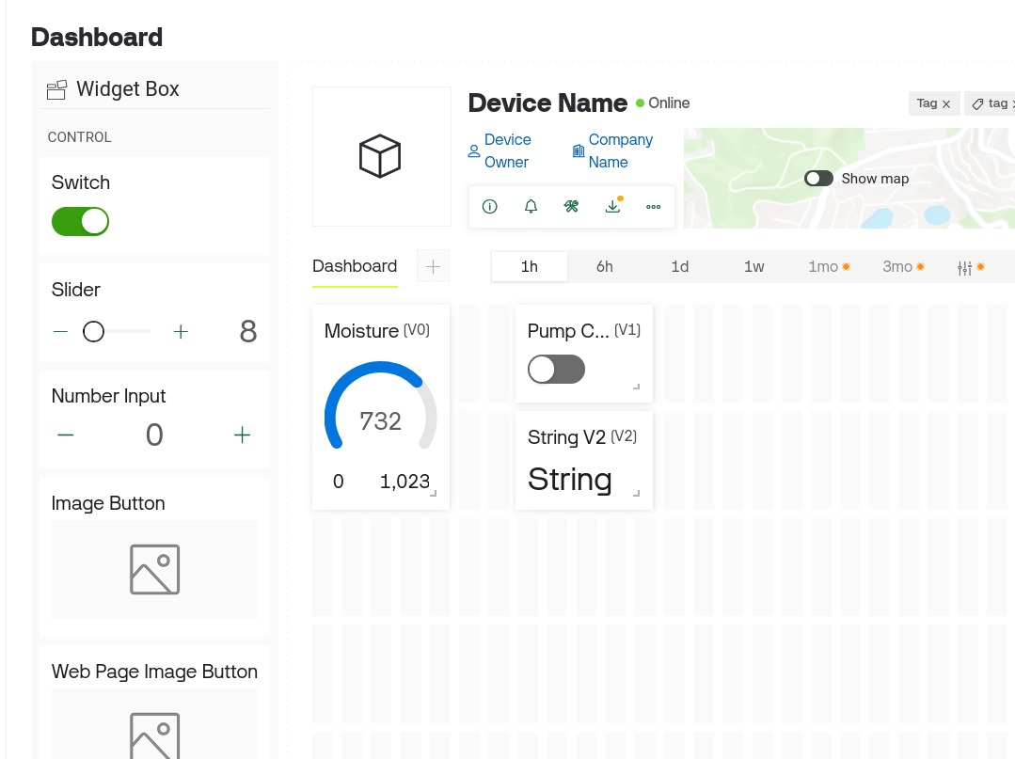
Figure 12 | Blynk Dashboard

Next, a device is created from the template, and a dashboard is designed in the Blynk IoT mobile application by adding widgets such as Gauge, Button, and Label. These widgets are mapped to the corresponding virtual pins. Once the NodeMCU is connected to the Wi-Fi network, it automatically communicates with the Blynk Cloud and starts transmitting sensor data in real time. The user can monitor the plant status, control the irrigation pump remotely, and receive instant updates through the mobile application, making the Smart Plant Watering System convenient, reliable, and efficient.

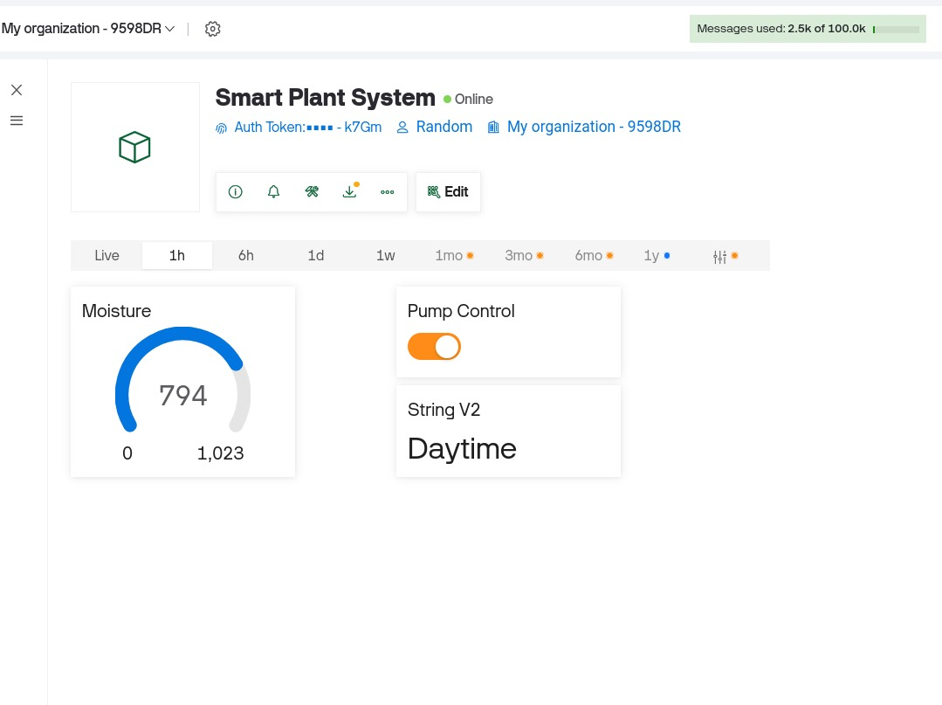

Figure 13 | Blynk Library Dashboard

3.2.5 Blynk Library

The Blynk Library is an open-source software library that enables communication between the NodeMCU ESP8266 and the Blynk Cloud. It provides a simple interface for connecting IoT devices to the internet and exchanging data with the Blynk mobile application. The library supports various microcontrollers, including ESP8266, ESP32, Arduino, Raspberry Pi, and other Wi-Fi-enabled development boards.
The Blynk Library simplifies the development of IoT applications by providing built-in functions for Wi-Fi connectivity, cloud communication, virtual pin management, and device synchronization. It allows developers to transmit sensor data to the Blynk Cloud and receive commands from the mobile application without implementing complex networking protocols. The library works together with the Blynk IoT Platform, making remote monitoring and control easy and reliable.
In the proposed Smart Plant Watering System, the Blynk Library is used to establish communication between the NodeMCU ESP8266 and the Blynk Cloud through a Wi-Fi connection. The library periodically uploads the soil moisture sensor readings and light status to the cloud and receives manual control commands for the water pump from the Blynk mobile application. It also synchronizes the pump status between the hardware and the mobile dashboard, ensuring real-time monitoring and control.
The project uses the following Blynk Library functions:
- Blynk.begin() – Connects the NodeMCU to the Wi-Fi network and Blynk Cloud using the Authentication Token.
- Blynk.run() – Maintains continuous communication between the NodeMCU and the Blynk Cloud.
- Blynk.virtualWrite() – Sends sensor values and device status to the virtual pins in the Blynk application.
- BLYNK_WRITE() – Receives commands from the mobile application and performs the required action, such as turning the water pump ON or OFF.
- BlynkTimer – Executes tasks such as reading sensor values and updating the cloud at predefined time intervals.

Chapter-IV: Work, Results and Analysis

4.1 Work
The circuit connection for the project "IoT-Based Smart Plant Watering System using NodeMCU ESP8266 and Blynk" is as shown in Figure 11. The Capacitive Soil Moisture Sensor, LDR Sensor, Relay Module, Mini DC Water Pump, and LED Indicator are connected to the NodeMCU ESP8266 development board. The VCC and GND pins of all the components are connected to the appropriate power supply pins of the NodeMCU. The analog output pin of the Capacitive Soil Moisture Sensor is connected to the A0 pin of the NodeMCU to measure the soil moisture level. The digital output pin of the LDR Module is connected to D2 for detecting the surrounding light condition.
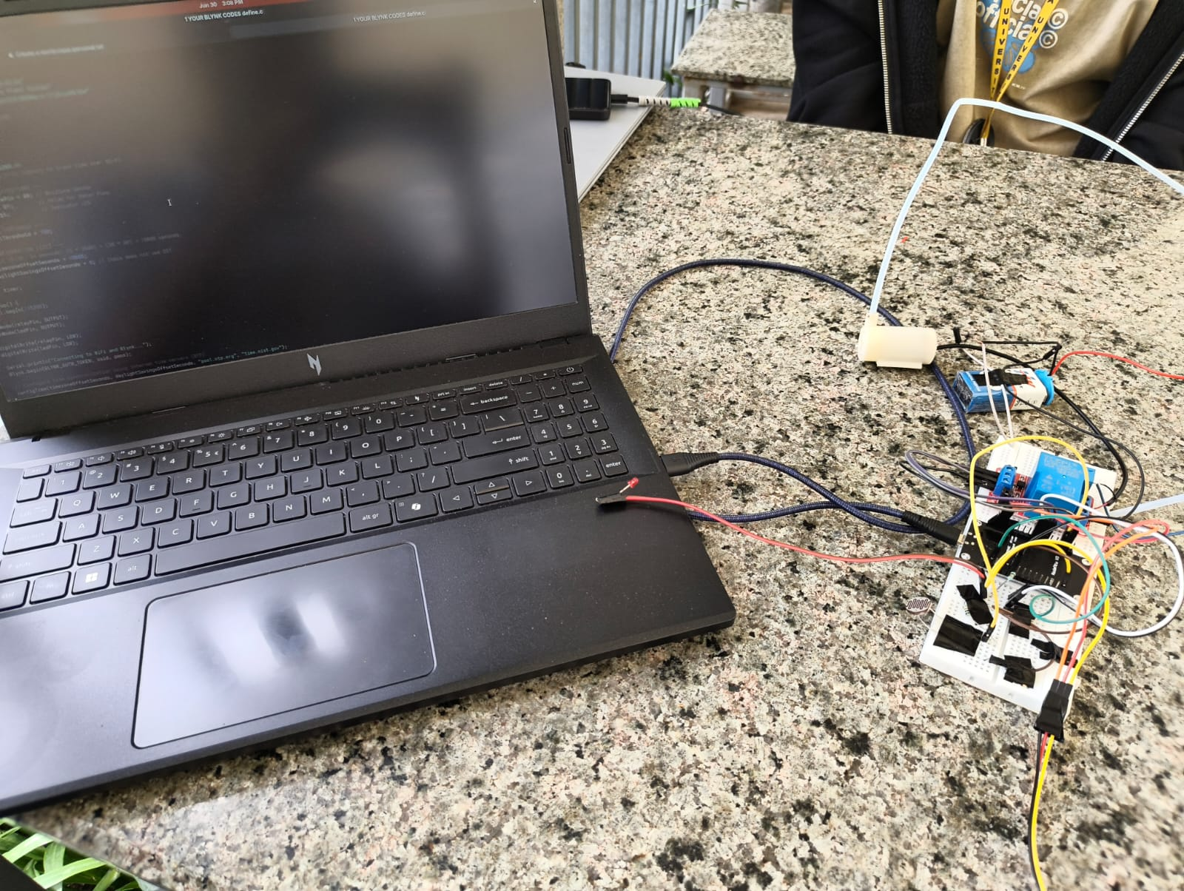
Figure 14 | Hardware Setup of Smart Plant Watering System

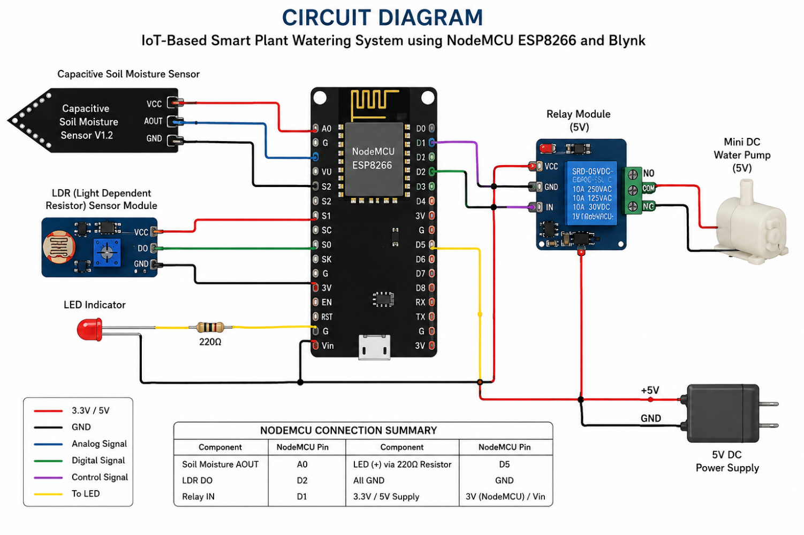
Figure 15 | Circuit Diagram of Smart Plant Watering System

The Relay Module is connected to digital pin D1 of the NodeMCU and is used to control the Mini DC Water Pump. Whenever the soil moisture value exceeds the predefined threshold (indicating dry soil), the NodeMCU activates the relay, which switches ON the water pump. After the required moisture level is achieved, the relay is deactivated, automatically turning OFF the water pump. An LED Indicator connected to digital pin D5 provides visual indication of the pump status by glowing whenever the pump is running.
The NodeMCU is programmed using the Arduino IDE with Embedded C language. During startup, the NodeMCU connects to the available Wi-Fi network using the configured SSID and password. Once connected, it establishes communication with the Blynk Cloud using the Authentication Token. The system periodically reads the soil moisture sensor and LDR sensor values and uploads them to the Blynk IoT Platform using virtual pins. The Blynk mobile application displays the current soil moisture value, pump status, and day/night condition in real time.

In addition to automatic watering, the system also supports manual control through the Blynk mobile application. The user can manually switch the water pump ON or OFF using the virtual button available on the dashboard. This feature provides flexibility for users to operate the irrigation system remotely whenever required.
The software program written below is used for the Project
// 1. YOUR BLYNK CODES
#define BLYNK_TEMPLATE_ID "TMPL3PZrU5LGa"
#define BLYNK_TEMPLATE_NAME "Smart Plant System"
#define BLYNK_AUTH_TOKEN "SYYnZGeGSZ8JHR0Nqrz-lTi9ruvKk7Gm"

// 2. PUT YOUR WI-FI DETAILS HERE
char ssid[] = "YOUR_WIFI_NAME";
char pass[] = "YOUR_WIFI_PASSWORD";

#define BLYNK_PRINT Serial
#include <ESP8266WiFi.h>
#include <BlynkSimpleEsp8266.h>

// --- PHYSICAL PIN DEFINITIONS ---
const int soilMoisturePin = A0; // Moisture Sensor
const int relayPin = D1; // Relay for Water Pump
const int ldrPin = D2; // Light Sensor
const int ledPin = D5; // Indicator LED

// --- AUTOMATION THRESHOLD ---
// NodeMCU analog pins read from 0 (wet) to 1023 (bone dry).
// Adjust this number based on your testing!
const int drySoilThreshold = 700;

BlynkTimer timer;

void setup() {
Serial.begin(115200);

pinMode(relayPin, OUTPUT);
pinMode(ledPin, OUTPUT);
pinMode(ldrPin, INPUT);

digitalWrite(relayPin, LOW);
digitalWrite(ledPin, LOW);

Serial.println("Connecting to WiFi and Blynk...");
Blynk.begin(BLYNK_AUTH_TOKEN, ssid, pass);

timer.setInterval(2000L, sendSensorData);
}

void loop() {
Blynk.run();
timer.run();
}

// --- SEND DATA TO CLOUD & CONTROL PUMP ---
void sendSensorData() {
int moistureValue = analogRead(soilMoisturePin);
Blynk.virtualWrite(V0, moistureValue);

// --- AUTOMATIC PUMP LOGIC HERE ---
// Note: Standard soil sensors read HIGHER numbers when the soil is DRY.
if (moistureValue > drySoilThreshold) {
digitalWrite(relayPin, HIGH); // Turn Pump ON
digitalWrite(ledPin, HIGH); // Turn LED ON
Blynk.virtualWrite(V1, 1); // Update the app button status to ON
Serial.println("Soil is DRY! Turning pump ON.");
} else {
digitalWrite(relayPin, LOW); // Turn Pump OFF
digitalWrite(ledPin, LOW); // Turn LED OFF
Blynk.virtualWrite(V1, 0); // Update the app button status to OFF
Serial.println("Soil is WET. Turning pump OFF.");
}

// Read Light Sensor
int lightValue = digitalRead(ldrPin);
if (lightValue == HIGH) {
Blynk.virtualWrite(V2, "Daytime");
} else {
Blynk.virtualWrite(V2, "Nighttime");
}
}

// --- MANUAL OVERRIDE FROM CLOUD ---
// You can still manually control it from the app if needed
BLYNK_WRITE(V1) {
int buttonState = param.asInt();

if (buttonState == 1) {
digitalWrite(relayPin, HIGH);
digitalWrite(ledPin, HIGH);
Serial.println("Manual override: ON");
} else {
digitalWrite(relayPin, LOW);
digitalWrite(ledPin, LOW);
Serial.println("Manual override: OFF");
}
}

4.2 Results and Analysis
The developed IoT-Based Smart Plant Watering System successfully performs automatic irrigation based on the soil moisture level. The NodeMCU ESP8266 continuously reads the analog output of the Capacitive Soil Moisture Sensor and transmits the measured values to the Blynk Cloud through Wi-Fi. The real-time soil moisture value, pump status, and light condition are displayed on the Blynk mobile application, allowing users to monitor the system remotely.
When the soil becomes dry and the moisture value exceeds the predefined threshold, the NodeMCU automatically activates the relay module, which turns ON the Mini DC Water Pump. Simultaneously, the LED indicator glows, indicating that watering is in progress. Once the soil moisture reaches the desired level, the controller switches OFF the relay and stops the water pump, thereby preventing overwatering and conserving water.
The LDR Sensor successfully detects the ambient light intensity and updates the Blynk dashboard with the current condition as Daytime or Nighttime. The manual override feature provided through the Blynk application allows users to control the water pump remotely whenever necessary.
The system operated reliably during testing and responded accurately to changes in soil moisture levels. Real-time communication between the NodeMCU and the Blynk Cloud was established successfully through Wi-Fi, enabling continuous monitoring and remote operation. The automatic watering mechanism reduced manual effort, minimized water wastage, and ensured that the plant received sufficient water only when required.
The Blynk dashboard displaying the soil moisture value, pump status, and light condition

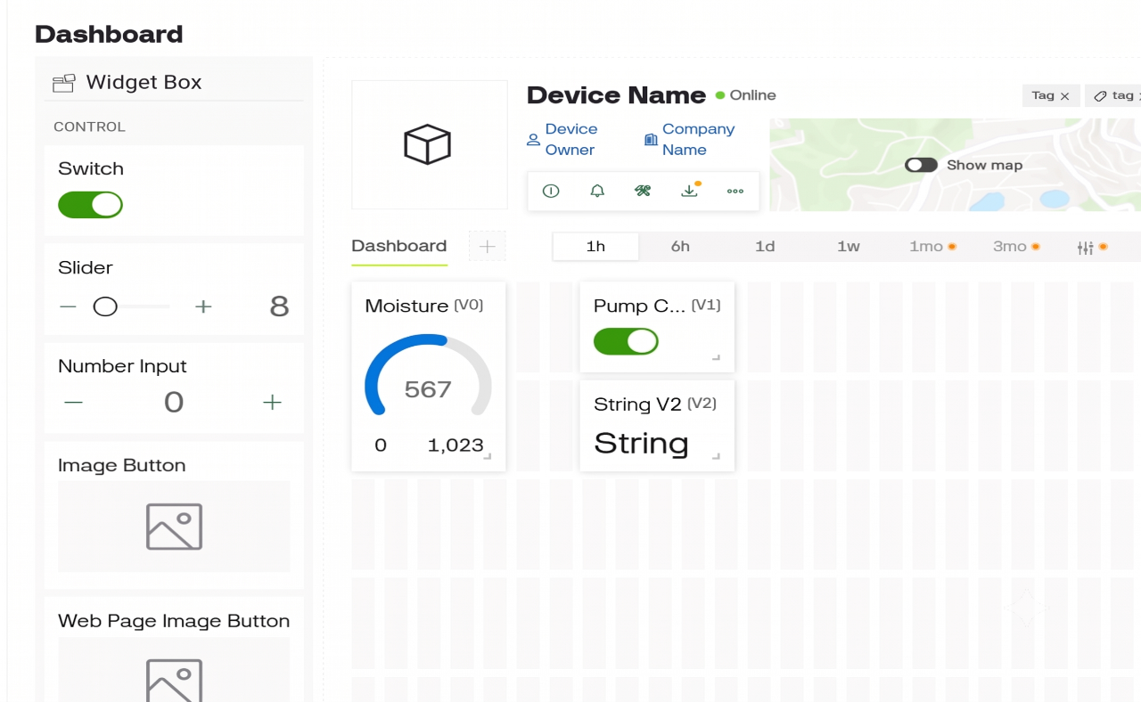

Figure 16 | Blynk Dashboard Analysis

Chapter-V: Conclusion & Future Scope
5.1 Conclusion
The IoT-Based Smart Plant Watering System using NodeMCU ESP8266 and Blynk has demonstrated an efficient and reliable solution for automatic plant irrigation and remote monitoring. The system integrates a Capacitive Soil Moisture Sensor, NodeMCU ESP8266, Relay Module, Mini DC Water Pump, LDR Sensor, and the Blynk IoT platform to monitor soil moisture in real time and automatically water plants whenever the soil becomes dry. The system successfully performs automatic irrigation based on predefined moisture threshold values while also allowing users to monitor and manually control the water pump through a smartphone application.
The integration of IoT technology enables users to access real-time soil moisture data, pump status, and light conditions from any location with an internet connection. This reduces the need for continuous manual supervision and ensures that plants receive the required amount of water at the appropriate time. The automatic watering mechanism minimizes water wastage, prevents overwatering, and promotes healthy plant growth. The use of NodeMCU ESP8266 with built-in Wi-Fi connectivity makes the system economical, energy-efficient, and suitable for smart home gardening, indoor plants, greenhouses, and small-scale agricultural applications.
Overall, the proposed system demonstrates the practical implementation of embedded systems, sensors, wireless communication, and IoT technology in developing an intelligent irrigation solution. The project provides an affordable, user-friendly, and effective approach to automated plant care while encouraging efficient utilization of water resources.

5.2 Future Scope
The proposed Smart Plant Watering System can be further enhanced by integrating additional features to improve its functionality and efficiency. A water level sensor can be incorporated to monitor the water level in the storage tank and notify the user when refilling is required. Integration with weather forecasting APIs can enable the system to delay irrigation during expected rainfall, thereby conserving water. The system can also be extended to support multiple plants by using additional soil moisture sensors and relay-controlled pumps.
Future versions may include AI and Machine Learning algorithms to analyze historical soil moisture data and predict optimal watering schedules based on plant type and environmental conditions. The system can also be powered using solar energy, making it more suitable for outdoor and remote agricultural applications. Additional features such as mobile notifications, data logging, graphical analysis of moisture trends, and voice assistant integration can further improve user convenience and make the system a complete smart irrigation solution for modern agriculture and home gardening.

References
- Jash Doshi, Tirthkumar Patel, "Smart Farming using IoT, a Solution for Optimally Monitoring Farming Conditions," Procedia Computer Science, Volume 160, 2019, Pages 746–751.
- Pravin Rajesh Nawate and Shivani Janardhan Kshirsagar, "IoT Base Temperature Data Logger using ThinkSpeak Cloud and Auto Excel Report Generation," International Journal of Advance Research and Innovation, ISSN: 2347-3258, Volume 9, Issue 4, 2021, Pages 325–328.
- Sharmad Pasha, "ThingSpeak Based Sensing and Monitoring System for IoT with MATLAB Analysis," International Journal of New Technology and Research (IJNTR), ISSN: 2454-4116, Volume 2, Issue 6, June 2016, Pages 19–23.
- S. R. Nandurkar, V. R. Thool, and R. C. Thool, "Design and Development of Precision Agriculture System Using Wireless Sensor Network," IEEE International Conference on Automation, Control, Energy and Systems (ACES), 2014.
- V. Suma, "Internet of Things (IoT) Based Smart Agriculture Monitoring System," International Journal on Recent and Innovation Trends in Computing and Communication (IJRITCC), Volume 5, Issue 2, 2017.
- Blynk Inc., Blynk IoT Platform Documentation, Available: https://docs.blynk.io/
- Espressif Systems, ESP8266EX Datasheet, Espressif Systems, Available: https://www.espressif.com/
- Arduino, Arduino IDE Documentation, Available: https://docs.arduino.cc/software/ide-v1/
- Capacitive Soil Moisture Sensor V1.2 Datasheet, DFRobot Electronics, Available: https://wiki.dfrobot.com/
- Songle Relay SRD-05VDC-SL-C Datasheet, Songle Relay Manufacturer.

